Please enclose this slip with the winner artwork submissions.

Chinese New Year School Arts Competition- 2024
Exhibition Launch Party at the Diamond, University of Sheffield, Thursday 21 March, 5pm.
School Name:
School Address:
Headteacher:
School Representative(s): | Name(s):
 | School Email:
 | Contact Tel:

Submit the original winning artwork to 2-4 Palmerston Road, Sheffield S10 2TE by 1st March 2024.
Winners’ names (please use block capital letters if hand-written to reduce spelling mistakes on the certificates):
Category | Key Stage 1, Year 1-2 |  | Category | Key Stage 2, Year 3-4 |  | Category | Key Stage 2, Year 5-6
First Prize |  |  | First Prize |  |  | First Prize
Runner-up |  |  | Runner-up |  |  | Runner-up
Runner-up |  |  | Runner-up |  |  | Runner-up
Total Number of Participants |  |  | Total Number of Participants |  |  | Total Number of Participants

Has school registered attending the Exhibition Launch Party through Google Form? Yes □ Not Yet □
Google Form: https://forms.gle/ApjLwgsaDTSPwzSJ8
List the number of attendees for the Launch Party
Number of school staff attending | Number of Winners attending | Number of family/friends attending

If your school cannot attend the Launch Party, winners’ prizes, certificates, and the original artwork will be returned to school after the Exhibition week on 25 – 28th February 2024.
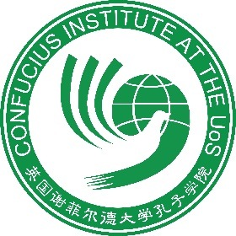
Contact us:
Confucius Institute at the University of Sheffield
2-4 Palmerston Road, Sheffield S10 2TE
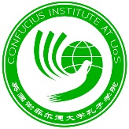
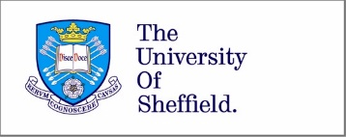
Email : confucius@sheffield.ac.uk Tel: 0114 2228332 / 07593502130

