Worksheet: Using EXCEL to calculate probabilities for the normal distribution
Use the following function to obtain the probability of observing a value less than or equal to ‘value’:
NORM.DIST(value, mean, SD, TRUE)

For example, let us assume we have a distribution with mean =3.4 and SD=0.57 and want to work out the following probabilities:
P( X > 4.5)
P( X <= 2.3)
P( X > 2.3)
P(X between 2.3 and 4.5)

To obtain these in EXCEL we input the following data:
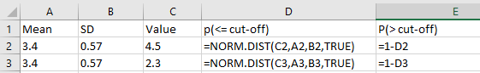

And here’s what EXCEL displays:
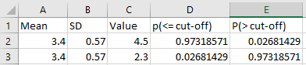

Thus:
P(> 4.5) = 0.0268
P(<= 2.3) = 0.0.0268
P(> 2.3) = 0.9732
P(between 2.3 and 4.5) = 0.9732 – 0.0268 = 0.9464

