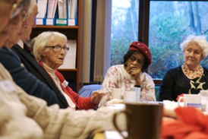
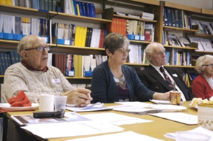
Palliative Care Studies Advisory Group
TERMS OF REFERENCE
Background
The Palliative Care Studies Advisory Group (PCSAG) is a group of friendly local people who work closely with researchers from the University of Sheffield, to advise on current and future research in palliative care. The group was established in 2009 to bring together patients, carers and members of the public to get involved in research. Getting involved in research can be interesting, rewarding and enjoyable and helps researchers ensure their research is relevant, appropriate and influential.

Purpose / role of the group:
The role of the Palliative Care Studies Advisory Group is to give advice and guidance to researchers who are working in palliative and end of life care. The aim in setting up the group was to harness the skills and perspectives of interested patients, carers and members of the public in order to improve the design, implementation and dissemination of research.

The aims of the PCSAG are to:
- Provide open and transparent input into palliative and end of life care research e.g. research methods, recruiting patients, collecting data and ethical issues
- Help suggest ideas for new research areas, and prioritise research areas
- Comment on applications for funding to support new research
- Advise us on ways of sharing results and publicising our research
- Assist in raising awareness of research
- Help us develop links with local consumer research groups and patient and carer organisations

Membership:
Anyone with experience of palliative / end of life care or hospice can join. This includes patients, family members and friends, and interested members of the public. Membership of the group is open ended, and many members have been involved over a number of years. However we also welcome members who would only like to be involved for a shorter time. Group members may leave at any time.

Working Methods and Meetings:
The PCSAG meet in Sheffield approximately twice a year. The group co-ordinator Clare Gardiner will organise these meetings and researchers can apply to have their projects reviewed at a meeting, or for issues to be placed onto the agenda. An agenda for each meeting is circulated via post and email prior to the meeting and made available for individuals at the meeting. During each meeting researchers will present information about their projects and ask questions for the group to discuss. Minutes are taken and are shared after each meeting. Meetings typically last three hours and lunch and breaks are included.
In addition to the meetings in Sheffield, we regularly communicate by e-mail and researchers will sometimes ask for feedback on their research via e-mail. Group members who do not have access to e-mail can receive these communications by post if they wish.

Expenses and reimbursement
Members of the PCSAG do not receive any payment for their involvement, however all travel expenses are covered including train, taxi, bus, mileage and car parking. Lunch and refreshments are provided at every meeting. Members will be informed of any relevant training opportunities as and when they arise.

Accountability and review
Clare Gardiner is currently the co-ordinator of the PCSAG and will organise and chair meetings. Any issues or complaints should be directed to Clare Gardiner, or to Prof Tony Ryan, Director of Research at the School of Nursing. E-mail: t.ryan@sheffield.ac.uk, Tel: (0)114 222 2062. These terms of reference will be reviewed every three years.

Definition of key terms: “Palliative care is the active holistic care of individuals across all ages with serious health-related suffering due to severe illness, and especially of those near the end of life. It aims to improve the quality of life of patients, their families and their caregivers”

Contact:
Dr Clare Gardiner - PCSAG Co-ordinator
School of Nursing & Midwifery
The University of Sheffield, Barber House Annexe
3a Clarkehouse Road, Sheffield S10 2LA
E-mail: c.gardiner@sheffield.ac.uk
Tel: 0114 222 2038

