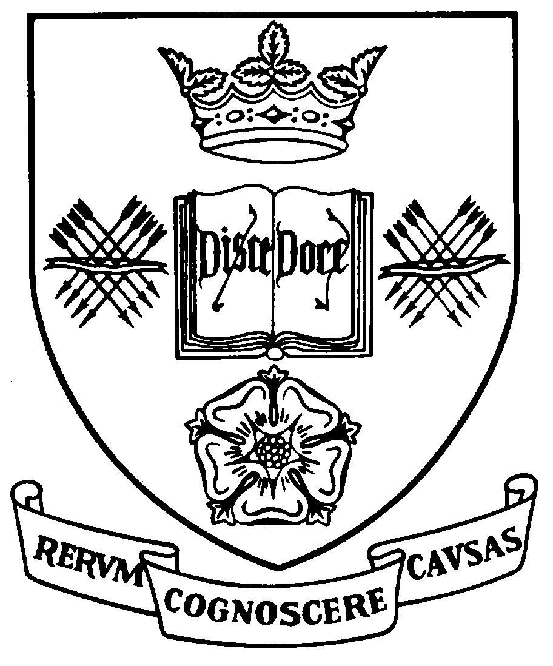
Programme Specification
A statement of the knowledge, understanding and skills that underpin a taught programme of study leading to an award from
The University of Sheffield

1 | Programme Title | Early Modern History
2 | Programme Code | HSTT45 (Full-time), HSTT59 (Part-time)
3 | JACS Code | V140
4 | Level of Study | Postgraduate
5 | Final Qualification | MA
6 | Intermediate Qualification | Postgraduate Diploma
7 | Teaching Institution (if not Sheffield) | Not applicable
8 | Faculty | Arts and Humanities
9 | Home Department | History
10 | Other Departments involved in teaching the programme | None
11 | Modes of Attendance | Full-time or Part-time
12 | Duration of the Programme | 1 year or 2 years
13 | Accrediting Professional or Statutory Body | None
14 | Date of production/revision | May 2010; revised August 2011; revised April 2015; revised March 2016, revised March 2018, revised March 2019
- Background to the programme and subject area
Knowledge and understanding of the human past is of incalculable value both to the individual and to society. Studying history provides a distinctive education by providing a sense of the past and its separation from the present, together with an awareness of the development over time of different values, systems and societies.
Completing a MA degree in History at Sheffield enhances students’ critical and organisation skills, equipping them to undertake independent historical research. It provides opportunities for students to acquire a high level of historical knowledge and understanding, explore a range of historical contexts, and develop and refine ICT, bibliographical and research skills.
The period of transformative change we know as ‘early modern’ has inspired some of the very best historical writing. In exploring the renaissance, the reformation or particular events such as the English Civil War or the French Revolution, historians have produced arguments and explanations that have influenced the entire discipline of history. The long and exceptionally distinguished tradition in teaching and research in early modern history at the University of Sheffield continues with expertise spanning a range of periods, contexts and themes, including state formation, law and society, language and identity, cultural history, commerce and colonialism. A distinctive feature is the pioneering role the History Department has played in making early modern historical sources available in electronic form. The Hartlib Project [http://www.shef.ac.uk/hri/projects/projectpages/hartlib], created electronic editions of texts produced by a group of millenarian thinkers during the English Civil War, so producing a research tool that has been used by both MA and doctoral students for independent research. The British Academy’s John Foxe project is producing a definitive online edition of the ‘Book of Martyrs’ [http://www.johnfoxe.org/] which, like the Hartlib papers, is used by scholars and researchers throughout the world. Another major project, the Old Bailey trial accounts between 1670 and 1834 [http://www.johnfoxe.org/] , has had great public impact and has given rise to on-going projects on ‘Plebeian Lives and the Making of Modern London, 1690-1800’ and the Proceedings of the Central Criminal Court, both of which will provide students with ready access to new sources for their own research.
The Department of History at the University of Sheffield is one of the most active centres for teaching and historical research in the country. In the latest Research Excellence Framework exercise (2014), we were ranked third nationally in the overall ranking and second for outputs: both in terms of the average score of our books and papers (with a score of 3.30) and in terms of the overall quality: 45% of our research was judged 'world-leading' and 86% either 'world-leading' or 'internationally excellent'. This indicates the Department’s wider commitment to research-led teaching. A complement of over 40 members of academic staff gives the Department both chronological and geographical coverage, with research and teaching expertise in British, European, and North American and global history. Members of the Department of History have played a pioneering role in making historical sources available in electronic form, and these projects offer an example of how teaching and research are inter-linked within the department. An active departmental research culture of publishing, conferences and seminars ensures that the teaching of early modern history is informed by the most recent debates and research findings. Those teaching on the programme are thus well-placed to introduce students to academic controversy as well as current historical problems and issues. There are opportunities to participate in events organised by a number of research centres and clusters, such as the Sheffield Centre for Early Modern Studies (SCEMS).
The degree programme is designed both for students who wish to go on to advanced independent research up to doctoral level, and for those who wish to acquire a broad range of transferable skills and intellectual training that will be of value to employers outside academia. MA students from the Department regularly go on to undertake advanced study in History as well as to pursue careers in areas such as education, museums and libraries, tourism and the heritage industry, ICT in the humanities, the civil service, marketing and retail, and the media.
- Programme aims
Degree programmes offered by the Department of History have the following general aims consonant with the University of Sheffield’s Mission Statement:
- To provide high quality teaching at undergraduate and postgraduate levels that is informed and invigorated by research and scholarship and alert to the benefits of student-centred learning.
- To sustain a culture of research and learning that promotes the free pursuit of knowledge, impartial analysis and the acquisition of informed attitudes to the study of the past.
- To maintain broad access to its programmes of study for students from a wide range of educational and social backgrounds to the extent permitted by intellectual aptitudes which the programme demands.
- To respond to the diversity of student interests by offering an appropriate level of student choice within the degree programme, enabling them to pursue chronologically, geographically and methodologically diverse fields of study.
- To equip students with the skills that will prepare them for employment or for further study.
MA programmes in History are designed to meet the following level-specific aims
- To offer students a programme that is qualitatively different from BA-level study by maximising opportunities for independent study and reflexive practice.
- To focus on transferable research, learning and presentational skills that are applicable both within the academic discipline of History and in other professional settings.
- To help students to recognise their personal ability, motivation and interest in pursuing further study and to equip them with the skills needed for independent research at MPhil/PhD level.
- To improve students’ chance of developing a coherent and rigorous PhD proposal and obtain funding for further study.
The MA in Early Modern History has the following programme-specific aims enabling candidates who have completed the course to
- recognise and be aware of the distinctive presuppositions that underlie historical writing on the early modern period and the notion of ‘early modernity’.
- recognise the contribution made by other academic disciplines to the recent study of early modern politics, culture and society.
- identify and engage critically with historiographical debates about the early modern period.
- evaluate a range of early modern primary sources, employing appropriate analytical techniques and theoretical approaches.
- identify and explore both the historiographical context and the sources available for independent historical research on a chosen subject in early modern history.

17. Programme learning outcomes
Knowledge and understanding:
Students achieving either award of Postgraduate Diploma or MA will have developed:
K1 | a deeper awareness of early modern history, of the sources available to those writing it, and of the academic debates that inform this area of study.
K2 | a critical understanding of the historiography that defines the area of study and of how this relates to a student’s own research interests.
K3 | a comprehensive understanding of the distinctiveness of history as a discipline, and an ability to reflect on how other disciplines have influenced the development of historical method.
K4 | a conceptual understanding that enables the student to evaluate scholarly writing in history and to undertake informed source-criticism.
In addition, students achieving the award of MA will have:
K5 | achieved a personal understanding of whether or not they possess the ability, motivation and interest to pursue further postgraduate study in History.

Skills and other attributes:
Students achieving either the award of Postgraduate Diploma or MA will have developed:
S1 | the ability to reflect deeply on historical knowledge and to demonstrate an awareness of current historical debates.
S2 | The ability to write and speak about the past in good English, showing an awareness of History as a literary discipline and a developing sense of literary style.
S3 | The ability to use a wide range of bibliographical tools (on paper and in electronic form) to locate and critically evaluate appropriate sources and materials for the advanced study of history.
S4 | The ability to locate and critically evaluate archival, printed or electronic source-material for the investigation of specific historical questions.
S5 | The ability to formulate and sustain independent historical arguments, to provide appropriate evidence to support them, including quantitative and visual evidence, and to reference the sources of the evidence used.
S6 | The ability to respond constructively to debate and criticism.
S7 | Effective skills in oral communication to specialist and non-specialist audiences.
S8 | Skills in effective time management, including the ability to work productively alone.
S9 | Familiarity with a variety of ICT skills, encompassing a range of bibliographical, statistical and other computer programmes and their application, as well as electronic sources for research.
In addition, students achieving the award of MA will have developed:
S10 | developed the ability to identify an area of historical enquiry and engage in independent historical research.
S11 | The ability to engage in independent and extended research within a defined area of historical enquiry, to construct and sustain a logical and where possible original argument based on information collected, and to present the findings in dissertation form, with a recognised scholarly apparatus.
18. Teaching, learning and assessment
Development of the learning outcomes is promoted through the following teaching and learning methods:
Introduction to the advanced study of history is available from the first semester of the programme through tutor-led classes for the optional module Research Skills for Historians. These cover defining a research topic, bibliographical and information skills, and approaches to different sorts of written and non-textual sources (S3-4, S8). General ICT induction is also provided in this module (S9) via demonstration classes led by our IT & Learning Technology Manager; more specialised, hands-on computer training is available from CICS where needed. Oral skills are developed through a core 15 credit module, Research Presentation, taught in semester 2 (S7). This encourages communication and presentation skills, including technical competence in Power Point, how to present data effectively, the use of visual material etc.
Further study-skills advice, including guidance on the professional presentation of written work using the appropriate scholarly apparatus (i.e. footnotes and a stratified bibliography) is provided to students via the departmental Style Guide.
Seminars are used throughout the year to encourage oral expression and the exchange of informed views, the concise summary of complex arguments and the ability to respond constructively to the presentation of alternative views. Some seminars take the form of discussion classes, exploring specific historical problems or methodological issues (the 30 credit, programme-specific core module taught in semester one and the 15 credit approved modules taken in either semester) (S1, S5, S7; K1-4). Seminars may be staff or student-led, as students work within small groups for taught classes, focusing on the specific historiographical or evidence-based themes and problems appropriate to their field of study.
Guided reading is a principal component of independent study. It allows students to develop and reinforce their awareness of historical knowledge and debate (K1-5, S1, S10), to reflect on different methodological approaches and to refine their own historical interests (K4). It furthers their bibliographical skills and enables them to make effective use of library and internet resources (S3-6).
Written assignments encourage students to develop their ability to summarise material critically, to present coherent and independent arguments in good English, and to support their arguments with appropriate evidence. Preparing such assignments, particularly defining and researching an appropriate topic and formulating independent questions, is essential to the acquisition of historical knowledge and understanding (K1-3, S1, S10). As both the form and the length of written assignments varies, students develop an appropriate range of learning and time-management strategies in response to them (S2-6, S8).
Individual tutorial guidance is given to all students undertaking the Dissertation and also to students who wish to receive guidance on preparing a research proposal and application for further study and associated funding (K4).

Opportunities to demonstrate achievement of the learning outcomes are provided through the following assessment methods:
All forms of assessment used on the programme evaluate students’ acquisition of historical knowledge and understanding, particularly K1-4, and K5. Assessment also serves a formative function to monitor students’ progress and provide learners with the feedback they need to evaluate their own progress and reflect upon the historical understanding they have acquired (S1). In the core module students are invited to submit up to 2,000 words of a draft / plan / piece of exploratory writing in advance of their final essay. Feedback on coursework encourages students to respond effectively and positively to constructive criticism by reflecting both on their skills of argument and presentation and on the coherence of their understanding of particular historical problems (S6-7). All assessment which contributes marks towards the degree, and therefore has a summative as well as formative function, is marked in accordance with published marking criteria.
Oral performance is assessed via the Research Presentation (semester 2) when each student gives a formal presentation about their research to other MA students and a representative selection of academic staff. This takes place during the second semester in the Research Presentation module and represents 100% of a student’s overall mark for that module. The presentation tests the students’ ability to convey the significance and intellectual content of research; the clarity and fluency of their communication skills; the effectiveness and imagination of their use of illustrative material; and their confidence in handling of questions, defending the coherence of their argument while respecting the opinions of others (S2, S6, S7).
Collectively, the portfolio of written assignments which students will produce for the assessment of the taught modules demonstrates acquisition of learning outcomes K1-4. This includes a range of technical exercises (including a bibliography for the dissertation) which are assessed on the basis of the students’ technical proficiency in execution of the task set; the range of material located; the critical assessment offered by the student of the usefulness of the material collected and their informed awareness of any problems, (S2-3; K1-4). Historiographical and methodological essays written for the core and optional modules also test students’ ability to identify a suitable topic for analysis, their familiarity with the relevant theoretical issues and their ability to handle theoretical or methodological material and to use an appropriate vocabulary in discussion as well as their critical and analytical capacity (K5, S4). In assignments for optional modules such as Presenting the Past; History Writers’ Workshop and Work Placement, we assess students’ technical skills (for example, through their use of film, audio or digital technology) and communication skills for non-specialist audiences (S7, S9).
Successful preparation of a 15,000 word Dissertation demonstrates MA students’ ability to work independently (S7-8), to define and complete extended research projects (K4, S5, S10) and to present the results in a professional fashion (S2). The Dissertation also tests the ability to locate and analyse a body of primary source material and to undertake independent research on that material (S5, S11).

19. Reference points
The learning outcomes have been developed to reflect the following points of reference:
Subject Benchmark Statements
http://www.qaa.ac.uk/AssuringStandardsAndQuality/subject-guidance/Pages/Subject-benchmark-statements.aspx
Framework for Higher Education Qualifications (2008)
http://www.qaa.ac.uk/Publications/InformationAndGuidance/Pages/The-framework-for-higher-education-qualifications-in-England-Wales-and-Northern-Ireland.aspx
University Strategic Plan
http://www.sheffield.ac.uk/strategicplan
Learning and Teaching Strategy (2016-21)
https://www.sheffield.ac.uk/staff/learning-teaching/our-approach/strategy2016-21
The teaching ethos of the Department of History as articulated through its Postgraduate Committee and the annual Away Days held to reflect upon Departmental practice in teaching and research.
The research interests of academic staff and the Department’s research strategy.
The AHRC’s guidance on ‘BGP Research Preparation Masters Studentships’, published in 2008
20. Programme structure and regulations
The programme is modular in format. To be awarded the degree of MA, students will successfully complete modules totalling 180 credits over 1 year (full-time study) or 2 years (part-time study), this includes 120 credits of taught modules plus a dissertation worth 60 credits.
Students will take two compulsory taught modules: Early Modernities (30 credits) in semester one and Research Presentation (15 credits) in semester two. The remaining 105 credits of taught modules allow students to broaden their knowledge of early modern history, further enhance their research skills and develop their skills in public history. The flexibility of the programme allows students to focus on their own specific interests and skills.
Full-time students will normally take 60 credits of taught modules in each semester, to ensure that their workload is evenly balanced. Work on defining the dissertation topic will begin early in the Autumn Semester and research will continue throughout the year, with the period between the end of the Spring Semester and the beginning of September being devoted entirely to the dissertation.
Part-time students will normally take 45 credits of taught modules in each semester of the first year of study and 15 credits of taught modules in each semester of the second year of study, to ensure that their workload is evenly balanced. Early Modernities will be taken in the first year and Research Presentation will be taken in the second year. Work on defining the dissertation topic will begin early in the Autumn Semester of the second year and research continue throughout the year, with the period between the end of the Spring Semester and the beginning of September being devoted entirely to the dissertation.
The Postgraduate Diploma in Early Modern History is awarded to students who successfully complete 120 credits of taught modules but do not undertake the Dissertation.
Detailed information about the structure of programmes, regulations concerning assessment and progression and descriptions of individual modules are published in the University Calendar available on-line at http://www.sheffield.ac.uk/calendar/regs.
21. Student development over the course of study
The MA in Early Modern History provides high-quality, research-led training for students both for students intending to proceed to research degrees and for those wishing to acquire a broad range of transferable skills and intellectual training that will be of value to employers outside the academic field of History.
The combination of compulsory and optional modules allows both full- and part-time students to further their own interests, broaden their field of knowledge and, at the same, hone the research skills needed for the dissertation. The core modules, Early Modernities and Research Presentation, train students in the skills and methods necessary for advanced historical study and the pursuit of independent research.
Early Modernities locates students within the key themes and debates of early modern history and provides them with an understanding of how the historiography has developed. Students also explore various technical and methodological issues raised by the advanced study of early modern history, how archives are assembled, for example, as well as broader questions around the codification of knowledge. Research Presentation helps students to develop and refine their personal presentation skills, these skills are valuable to both students looking to enter employment or intending to go on to doctoral study.
The optional Research Skills for Historians module, gives students training in advanced bibliographical management skills and in ICT, an introduction to recent debates over the nature of History as a discipline and the audiences for history, as well as training in the handling and managing research data. The complementary 15 credit, content-led modules equip students with an intellectual and historiographical context from which to undertake detailed exploration of a particular period or problem in early modern history, so enhancing their analytical and research skills.
The seminar-based learning, written papers and the portfolio of technical and presentational exercises (section 18 above) undertaken in these taught modules are structured so as to enable students to carry out supervised research.
The dissertation enables students to develop their own independent research topic within the field of early modern history, drawing on and demonstrating the knowledge and research techniques acquired through the taught modules (both through seminars and consolidated through the assessment).
Students who wish to take relevant language training may take suitable modules from those offered elsewhere in the University (subject to availability and the formal approval of Director of MA Programmes).
22. Criteria for admission to the programme
Applicants are expected to have a good first degree in History or a related discipline. Our standard requirement is a 2.1 classification, or equivalent, in a Bachelors degree from a recognised UK or overseas university. Applicants who have not studied History at undergraduate level will be expected to demonstrate commitment to and academic preparedness for advanced study in History. This might be via an interview or by the submission of written work, as requested by the Director of MA Programmes during consideration of the application. All students should be able to function effectively in an academic setting and to produce clear, independently reason, well-structured written work and oral arguments. An upper second class degree or its equivalent would normally be taken as an indicator of these threshold levels.
Non-native speakers of English should demonstrate proficiency in English through one of the University approved language tests, for example an IELTS average of 7 with at least 6.5 in each component. Further details are available on the university webpages at www.sheffield.ac.uk/postgraduate/info/englang
Detailed information regarding admission to the programme is available on the department of History web pages at www.sheffield.ac.uk/history/study/ma and the University webpages at www.sheffield.ac.uk/postgraduate
For more information students can contact the Admissions and Postgraduate Support Manager in the Department of History; history@sheffield.ac.uk; telephone 0114 222 2552.
23. Additional information

For further information students are directed to the Departmental web pages at: www.sheffield.ac.uk/history/study/ma and www.sheffield.ac.uk/history/research/strengths.
These provide full details about the content of the MA degree programmes, information about the research interests of individual members of staff and the research collections in Sheffield, as well as advice about how to apply and funding opportunities.
This specification represents a concise statement about the main features of the programme and should be considered alongside other sources of information provided by the teaching department(s) and the University. In addition to programme specific information, further information about studying at The University of Sheffield can be accessed via our Student Services web site at www.shef.ac.uk/ssid.

