

Programme Specification

A statement of the knowledge, understanding and skills that underpin a taught programme of study leading to an award from

The University of Sheffield

1 | Programme Title | Antimicrobial Resistance
2 | Programme Code | MBBT17
3 | JACS Code / HECoS Code | C500, C510 & C530 / 100353, 100906 & 100909
4 | Level of Study | Postgraduate
5a | Final Qualification | Master of Science (MSc)
5b | QAA FHEQ Level | 7
6a | Intermediate Qualification(s) | PgDip, PGCert
6b | QAA FHEQ Level | 7
7 | Teaching Institution (if not Sheffield) | Not applicable
8 | Faculty | Science
9 | Department | School of Biosciences
10 | Other Departments providing credit bearing modules for the programme | Infectious Diseases, Immunity & Cardiovascular Diseases
11 | Mode(s) of Attendance | Full-time or Part-time
12 | Duration of the Programme | 1 year or 2 years
13 | Accrediting Professional or Statutory Body | Not applicable
14 | Date of production/revision | October 2018, revised February 2022

15. Background to the programme and subject area

Antimicrobial Resistance (AMR) poses an increasingly serious threat to global public health and has become a major political, social and economic problem of our time. AMR ‘is no longer a prediction for the future, it is happening in every region of the world and has the potential to affect anyone of any age, in any country’ (WHO press release 2014). Drug resistant infections are already on the rise with up to 50,000 lives lost each year to antibiotic-resistant infections in Europe and the US alone. A failure to address the challenge of AMR could result in an estimated 10 million deaths every year globally by 2050, at a cost of £60-100 trillion in lost productivity to the global economy (Review on AMR chaired by Jim O’Neill, published Dec 2014, amr-review.org).

Effective methods to tackle AMR encompass a holistic ‘one health’ approach through global policies and robust implementation strategies. A key mechanism to implement change is through education. A better understanding of the prevention, spread and control of resistance will help limit the current and impending future threat. By addressing this unmet need, we aim to produce skilled personnel who are better equipped to tackle AMR and its future challenges. The MSc explores the science behind infection through to the current clinical situation and ways to protect our future; drawing on the life sciences, medicine, politics, social sciences and beyond to develop a comprehensive understanding of the global threat of AMR.

The Florey Institute aims to address the challenge of infectious disease, with a focus on antimicrobial resistance and host pathogen interactions. By encouraging growth, and the consolidation of research in this field, the Florey Institute now has the reputation, standing and strategic partners to be able to coordinate and deliver a high quality, interdisciplinary MSc in antimicrobial resistance. The programme will be led from the School of Biosciences, but also includes input from several departments including Chemistry, The Medical School, Infection, Immunity & Cardiovascular Disease, Politics, School of Health and Related Research, Chemical & Biological Engineering, The School of Clinical Dentistry. Some teaching components have also been developed and will be delivered by members of the NHS, including practicing clinicians. The course also includes guest lectures and workshops from biotech, pharma and government.

The programme will give students a broad yet comprehensive education in antimicrobial resistance, preparing them for further study through a PhD, or a future career in pharma/biotech, public health or policy making. The multidisciplinary skills acquired through the course will also equip the student with transferable skills that could be applied to other societal challenges and research areas outside the remit of AMR.

Further information about the programme may be found at: https://www.sheffield.ac.uk/postgraduate/taught/courses/2022/antimicrobial-resistance-msc

16. Programme aims
- To provide students with a cutting edge view of antimicrobial resistance across several disciplines.
- To provide students with fundamental knowledge of infectious disease, current therapeutic strategies and how antimicrobial resistance arises.
- To address the current and potential national and international mechanisms used to prevent AMR, including policies, alternative approaches and new drug targets.
- To give an insight into the process of developing new antimicrobials and the challenges involved in this process.
- To train students to assimilate information from scientific literature and interpret published data critically as well as understand experimental design to ultimately hypothesise and design their own experiments.
- To provide the opportunity for students to develop a multidisciplinary and transferable skill set.

17. Programme learning outcomes

Knowledge and understanding:
K1 | Detailed and critical knowledge, including knowledge of the most recent advances in selected areas relevant to antimicrobial resistance.
K2 | Practical understanding of the nature of scientific knowledge, and of techniques and tools for searching the scientific literature.
K3 | Familiarity with a relevant laboratory equipment and molecular methods, including knowledge of safe working practices.
K4 | Knowledge of numerical, graphical, statistical and other methods for analysing experimental data.
K5 | Familiarity with a range of presentation techniques.
K6 | Experience of an individual research project on a relevant topic.
K7 | An understanding of ethical issues, the relevance of public understanding of science and the responsibilities of the researcher.

Skills and other attributes:
S1 | Plan and manage their own learning, including time management skills and assimilate information effectively from a range of resources, including lectures, textbooks, websites and scientific literature.
S2 | Conduct and design, with appropriate training, new experimental techniques using a range of different laboratory equipment and protocols.
S3 | Evaluate and critically analyse experimental data.
S4 | Obtain and confidently deploy methods of oral, written, numerical, graphical and visual presentations for scientific reporting and communication.
S5 | Research and evaluate primary and secondary scientific literature relevant to a specific topic.
S6 | Read and appraise primary and secondary literature.
S7 | Organise and manage an independent research project to a professional standard.
S8 | Effectively work as a team.

18. Teaching, learning and assessment

Development of the learning outcomes is promoted through the following teaching and learning methods:
- Lectures and seminars.
- Practical classes.
- Research project.
- Literature review.
- Tutorials.
- Independent study.
- Debates and group discussions.
- Problem solving/example classes.
- Option to undertake work shadowing/observation within the NHS.

Much of the factual knowledge will be conveyed through lectures and seminars (K1). Additional advanced knowledge will come from attendance of departmental and Florey Institute seminars (K1). Students are expected to supplement lectures with directed independent study (S1, S7). Students will be required to search for (S6, K2) and critically analyse (S7) scientific literature relevant to the topic of AMR for assessed essays and for a literature review. The research project must involve an element of scientific research which may or may not be within a research laboratory and can be in any discipline provided it has an antimicrobial theme. In all cases, students will be under the supervision of an experienced academic member of staff with guidance on how to produce the final written project report.

Opportunities to demonstrate achievement of the learning outcomes are provided through the following assessment methods:

The assessment of the first two modules will involve a formal examination with multiple choice, short answer and essay questions. Students will be given other written forms of assessment with rapid feedback prior to these examinations, identifying those who may require further assistance in their writing methods; support will be given to those who require it. Written assignments will be screened with plagiarism software. Plagiarism, collusion and double submission will be managed according to University rules.

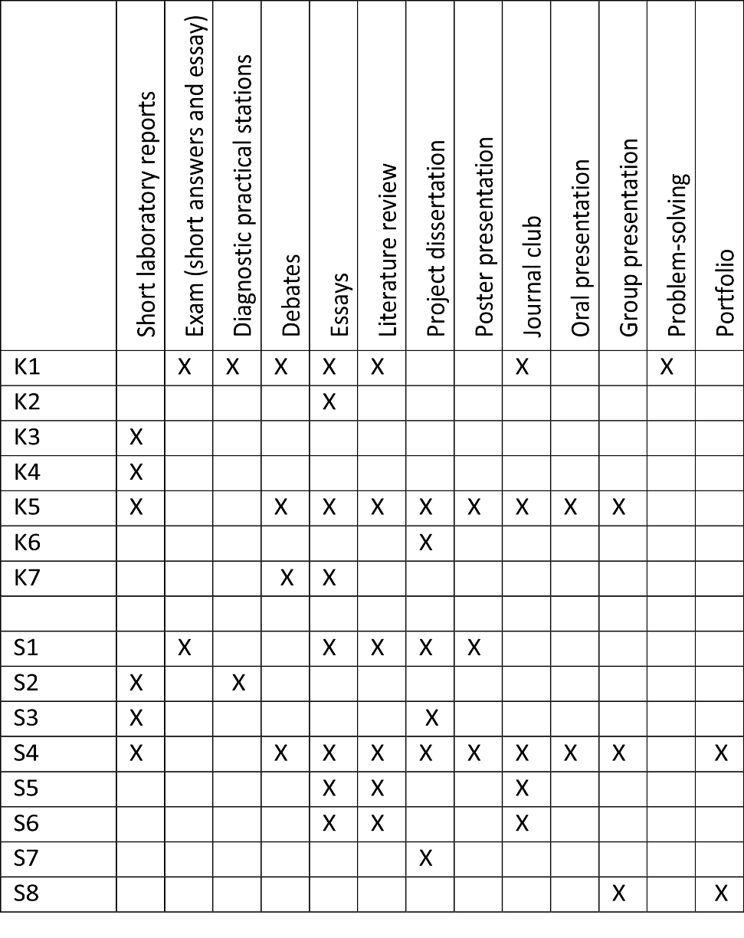

19. Reference points

The learning outcomes and programme content have been developed with reference to existing PGT (QAA FHEQ Level 7) provision within the School of Biosciences. In agreement with the University’s Learning and Teaching Strategy, the programme has been designed to benefit from our excellent research-led teaching, and the programme-level approach ensures that students will develop broad skills which cut across individual modules and result in the development of deeper knowledge and understanding. In accordance with the vision set out in The Sheffield Masters Graduate, the programme is designed to allow students to deepen their discipline-based knowledge while at the same time gaining the confidence to apply this knowledge within local, national, and international contexts, and to encourage creative and strategic problem-solving skills which transcend the component disciplines.

20. Programme structure and regulations

All modules are considered to be core modules totalling 180 credits.

Infectious disease and antimicrobials 30 credits

AMR and current clinical practice 30 credits

Global policy, disease control and new therapies 30 credits

Research and communication across the disciplines 15 credits

Advanced Scientific skills 15 credits

Research project 60 credits

Detailed information about the structure of programmes, regulations concerning assessment and progression and descriptions of individual modules are published in the University Calendar available on-line at http://www.sheffield.ac.uk/calendar/.

21. Student development over the course of study

Students will complete six diverse and interdisciplinary modules over the year, ending with a Research project. Students will complete a range of assessments for which they will be fully prepared and will provide them with the skills they need for the research project module. Students will be given extensive and timely feedback throughout and extra support will be given in areas which require additional learning. This will be anticipated as students may come from many different academic backgrounds. Opportunities for reflection on ‘real life’ skills and career support will also be provided. A key component will be communication skills and students will have the opportunity to use a variety of different media and number of techniques to develop this critical life skill.

22. Criteria for admission to the programme

2:1 or equivalent university qualification in a relevant STEM subject.

Must demonstrate interest in AMR, infectious disease, microbiology and host-pathogen interactions, antibiotics and their use in healthcare, animals and agriculture, infection control and prevention strategies, public health, drug discovery and new therapies, policy, management and interdisciplinary research.

Applicants with professional experience may also be considered following interview.

In addition, international students where English is not their first language or who have not been taught in English will also have an IELTS mean of 6.5 (with a minimum of 6.0 in all 4 components).

23. Additional information

This course will be delivered by members of the Florey Institute and therefore the students attending will also become part of this institute. Details can be found on the website at http://www.floreyinstitute.com/.

This specification represents a concise statement about the main features of the programme and should be considered alongside other sources of information provided by the teaching department(s) and the University. In addition to programme specific information, further information about studying at The University of Sheffield can be accessed via our Student Services web site at http://www.shef.ac.uk/ssid.

