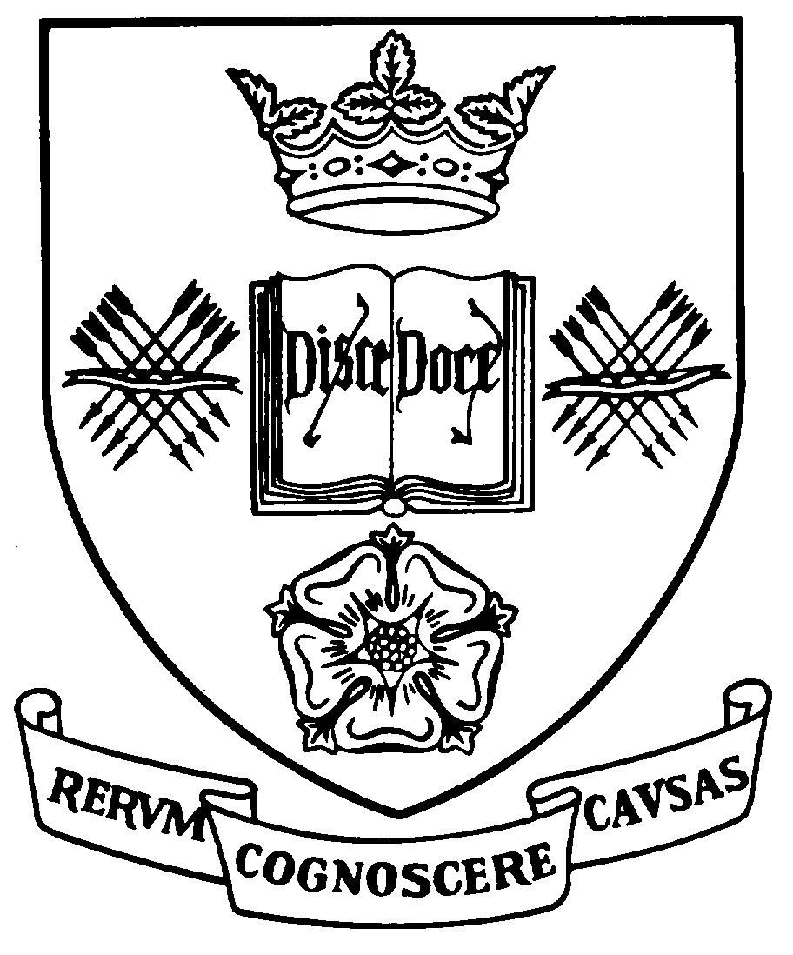

Programme Specification

A statement of the knowledge, understanding and skills that underpin a taught programme of study leading to an award from

The University of Sheffield
1 | Programme Title | History and Modern Language and Cultures
2 | Programme Code | MDLU09
3 | JACS Code | R000
4 | Level of Study | Undergraduate
5a | Final Qualification | Bachelor of Arts with Honours (BA Hons)
5b | QAA FHEQ Level | Honours
6 | Intermediate Qualifications | None
7 | Teaching Institution (if not Sheffield) | Not applicable
8 | Faculty | Arts and Humanities
9 | Department | School of Languages and Cultures
10 | Other Departments involved in teaching the programme | None
11 | Mode of Attendance | Full-time
12 | Duration of the Programme | 4 years (including two semesters spent in the relevant country/countries between Levels 2 and 3 of the programme)
13 | Accrediting Professional or Statutory Body | None
14 | Date of production/revision | January 2023
- Background to the programme and subject area

Languages play a vital role in today’s world. As noted in the QAA Benchmarking Statement for Languages and Related Studies (p.iv), ‘The importance of languages and related studies has been widely recognised at national and international levels’ and ‘the ability to use a foreign language is, by any definition, a useful acquisition and one which is held in high regard by employers.’ A high level of linguistic proficiency needs to be embedded in and complemented by a deep understanding of cultural context. As highlighted in its title, these two core elements (languages and cultures, in the broadest sense of the terms) lie at the heart of Sheffield’s BA Dual Honours in History and Modern Languages & Cultures degree. In addition to providing students with a rewarding educational experience, this degree seeks to build upon, enhance and enrich students’ prior learning aims to produce graduates with high level linguistic proficiency, excellent communication skills At the same time, taking advantage of the broad range of expertise offered by staff within the School (and complementing the research clusters focussing on topics including intellectual history, linguistics, literary studies, migration, postcolonial studies and visual cultures), the teaching of these languages is firmly situated within the ‘context’ of the countries and/or cultural contexts studied. Hence the teaching of ‘cultures’ is placed at the centre of this experience of learning the relevant ‘languages’, providing the students with valuable intellectual training, interpersonal and transferable skills, intercultural awareness, understanding and competence, and the capacity for critical analysis and independent thought. These aims are achieved in a vibrant environment through dynamic, high-quality and innovative research-led teaching that places students at the cutting edge of the discipline.

Students of the Dual honours in History and Modern Languages & Cultures degree programmes are not only able to benefit from the study of languages and cultures but complement this by focussing on another degree subject. They will develop a broader range of perspectives and gain an intercultural focus on their chosen subject outside language and cultures (for instance in the area of international relations, politics and history). They will enhance their knowledge of disciplines outside languages and cultures as well as make connections between their language/culture studies from the perspective of their dual subject.

The School of Languages and Cultures at the University of Sheffield is distinctive in its provision of a wide range of languages, some of which are less widely taught. Students are able to opt to study one or more languages at the relevant level from Catalan, Czech, Dutch, French, German, Luxembourgish, Portuguese, Spanish and Russian. Core and approved optional modules also offer a breadth of choice, enabling students to learn from specialists, enhance their knowledge and pursue individual research in topics such as identity, gender, linguistics, literary studies, politics and migration, covering a broad range of nations and periods (including the eighteenth, nineteenth and twentieth-centuries right up to the modern-day). A sound knowledge of (and practical competence in) the languages studied (appropriate to the relevant level) is essential to the study of these topics to enable students to both appreciate and understand the linguistic constructs at work and communicate their own ideas, whilst the fusion between ‘languages’ and ‘cultures’ is further enhanced through a range of approaches, and may include the teaching of languages and linguistics through translation and through opportunities for studying intercultural aspects across languages and cultures via School-wide modules. Students of the BA Dual Honours in History and Modern Languages & Cultures programme develop their intercultural awareness and communication skills - in addition to enhancing their personal attributes and gaining valuable transferable skills - through the experience of a year of study or working abroad in the country/ countries where the chosen language(s) studied is/are spoken. Depending on the language concerned, year abroad options may include university study, paid or unpaid placement work or a teaching assistantship at a diverse range of locations. (For instance, in the case of Spanish it is possible to spend the year abroad - often in a volunteering capacity - in one of the regions in the Iberian Peninsula, in one of the Spanish-speaking islands or in Latin America). The unique experience of spending a year abroad allows students to develop personally, academically and, in many cases, professionally. This first-hand engagement with languages and cultures is also mirrored at other levels, through a range of (external) engagement options which allow students to undertake research into languages and cultures in Sheffield, scaffolded by staff research expertise in a range of subject areas.

Students of the BA Dual Honours in History and Modern Languages & Cultures degrees are highly employable, not least because the valuable transferable skills and communication skills they gain are greatly valued by employers. Destinations for past graduates from the School of Languages and Cultures include business and finance, management, marketing, publishing, sales, education, teaching and government posts. A number take up employment overseas.
- Programme aims

Programmes offered by the School of Languages & Cultures are consistent with the general policy objectives enshrined in the Mission Statement of the University of Sheffield. In addition, they aim:

DISCIPLINE-BASED KNOWLEDGE

A1 To offer the opportunity to study the wide range of languages and cultures taught in the School of Languages & Cultures and the Modern Languages Teaching Session at the University of Sheffield and to support students as they learn:

a) to speak, read, write and understand the language(s) in a range of registers, styles and contexts;

b) to discuss the relevance of key historical, political events within the culture(s) studied through the study of key texts and media.

A key aim in this process is to inspire students to be passionate about their discipline and sensitize them to the inextricably close relationship between Languages and Cultures, the rewards derived from their study, their value and global impact.

SKILLS/ RESEARCH-LED TEACHING

A2 To foster the development of transferable skills (analytical, communicative, cognitive, cultural and practical) through high-quality teaching that takes advantage of the broad range of expertise of staff in the School of Languages & Cultures and places students at the cutting edge of their discipline. Students can engage with authentic and real-world challenges and will learn to critically analyse and interpret the language, literature, history and politics related to the specific language(s) and culture(s) they have chosen to study.

CREATIVITY, INDEPENDENT STUDY, RESEARCH AND REFLECTIVE LEARNING

A3 To provide students with opportunities for creative, independent study, collaborative learning and individual research and to encourage them to critically reflect on the learning process.

CHOICE, CONNECTIONS AND INTERESTS

A4 To respond to students’ diverse interests by providing a level of choice (as appropriate to the programme), to encourage students to make connections with (and interact with) disciplines within languages and cultures and beyond in accordance with their personal interests. The programme aims to encourage interests that can be sustained after graduation, either informally or through further formal study or research.

INTERCULTURAL AWARENESS

A5 To develop and enhance students’ intercultural awareness through the study of language, literature, history, politics and the experience of living abroad for a year. The programme particularly aims to enhance the students’ openness to other cultures and global outlook (i.e. their ability to understand and appreciate and adopt different perspectives and cultural practices).

DEVELOPMENT

A6 To encourage students’ involvement in extra-curricular activities and, through the period of residence abroad, foster their self-development (developing and enhancing their skills in adaptability, flexibility, problem solving, resilience, risk-taking, time management and so forth). The ultimate aim is to produce socially responsible graduates who will exhibit ethical behaviour, understand and communicate to others the invaluable contribution that a knowledge of Languages and Cultures can make to the workplace, society and the wider world.

SCHOLARSHIP, APPLICATION OF KNOWLEDGE AND EMPLOYABILITY

A7 To enable students to acquire skills (including interpersonal skills), experience and knowledge in one or more languages that will be valuable assets for a diversity of posts in the employment market and will help them to make a difference and provide an effective contribution to the society in which they will live and work.

17. Programme learning outcomes

DISCIPLINE-BASED KNOWLEDGE AND SKILLS

A) LANGUAGE COMPETENCE

KS1 speak, read, write and understand the language(s) in a range of registers, styles and contexts. (Link A1-A7).

B) CULTURAL COMPETENCE, CRITICAL THINKING

KS2 discuss the relevance of key historical, political events within the culture(s) studied through the study of key texts and media;

gain familiarity with essential primary and secondary sources;

critically analyse and interpret the language, literature, history and politics related to the languages and cultures studied. (Link A1-A7).

INTERCULTURAL AWARENESS & YEAR ABROAD

KS3 demonstrate intercultural awareness in a wide range of situations derived from the study of language, literature, history, politics and experience of living abroad for a year. (Link A1-A7).

INDEPENDENCE AND COLLABORATION

KS4 work independently and as part of a team deploying effective organisation, leadership and planning skills. (Link A1-A7).

CARRYING OUT RESEARCH

KS5 carry out and present the findings from research relating to the study of modern languages and cultures, using appropriate research and presentation skills. (Link A1-A7).

REFLECTION AND TRANSFERABLE SKILLS

KS6 critically reflect on the learning process including effective language learning strategies as well as the development of your professional skills and attributes. (Link A1-A7).

18. Teaching, learning and assessment

Development of the learning outcomes is promoted through the following teaching and learning methods:

Induction Procedures at Level 1 are designed to orientate the students towards the goals of the programme, acquaint them with the facilities available and develop basic bibliographic and study skills. They include year-group orientation sessions and a core 0-credit module at Level 1 (currently coded MDL121), offering interactive interventions designed to build their independent learning skills, understand the university context, support and resources available to them digital literacy (with a strong focus on autonomous language learning).

Lectures are used to impart essential knowledge relating to K1-K5 above. Some may be in the target language and therefore contribute to the development of receptive oral language skills as described above.

Seminars usually involve medium-sized groups engaging with a range of different activities including class discussions, group work and pair work. They may be staff-led or student-led and are used in three principal ways:
- At all Levels, seminars are used for target-language acquisition, focusing primarily on the receptive and productive skills in the relevant language(s) and the teaching of formal grammar. Students are exposed to as much authentic material in the target language as possible. Language seminars may be conducted in the relevant language(s) or English, depending on the level and nature/ objective of the seminar, and may include translation from the language of study.
- They are also used in conjunction with lectures and are designed to reinforce and consolidate information imparted through lectures by allowing students to work through, analyse, understand and respond to that information.
- Seminars are used as a key learning and teaching method for content modules studied, most commonly at Levels 2 and 3. They are designed to develop the ability to evaluate, argue, criticize and discuss, and also to deepen understanding of detailed aspects of a subject. They allow students to engage with the subjects under consideration in an active manner often on the basis of preparation work for each session. They thus contribute to the achievement of knowledge and understanding and to the development of key skills.

Oral work may involve small group work often with a native language speaker where students practise oral skills, both receptive and productive, and discuss key aspects of the relevant cultures.

Independent study is essential to the completion of the programme. New students are introduced to study skills through information in the online handbooks and within the Level 1 lecture and seminar programme. The independent study required is clearly set out in information provided to students, although it is recognised that the exact amount of time required to complete these tasks will vary from student to student. Independent study can be either individual or group based and therefore collaborative.

Individual/ independent study is required for the assimilation and further clarification of material gleaned from lectures, preparation for language and thematic seminars, preparation for written or oral assessments, and the broader development of knowledge of the field of study. The Year Abroad programme requires independent study in relation to a project relating to the country/ countries in which the student has spent a period of residence. Collaborative study can take the form of preparation for and delivery of seminars, for non-assessed class presentations and for group-based oral and written assessments at Levels 2 and 3. Independent study therefore contributes to the development of all the programme learning outcomes. Students are encouraged at all levels to make frequent use of library resources and the range of self-study facilities available.

The period of residence abroad during the third year of the programme is an essential part of the learning experience. It provides unrivalled opportunities for creative and everyday contact with native speakers, for the sustained exercise and development of both productive and receptive linguistic skills and for development of practical intercultural awareness to set alongside the theoretical awareness derived from the study of the language(s), cultural/ area/ linguistic/ literary studies and intellectual history and so forth. It also contributes to the development of personal resourcefulness and adaptability, together with other skills that will enhance employability. It therefore contributes to the development of all the learning outcomes.

Opportunities to demonstrate achievement of the learning outcomes are provided through the following assessment methods:

The assessment methods are designed to increase autonomy in student learning and include:

Regular formative assessment – usually in the form of periodic tests or exercises, which may be self-, peer- or tutor-assessed, or a combination of these. They are designed to reinforce knowledge and skills such as language production (both written and spoken) or intercultural understanding and may include translation to and from the target language. It is used at all Levels to carefully monitor the students’ progression through the programme and to identify areas for development.

Formative feedback is also used to provide timely and developmental feedback for students e.g. through running seminars, group and individual presentations, written work and a range of analytical pieces.

Within ‘grouped modules’ and/or pathways (most typically in the ‘Language + Culture’ (20 +20) credit blocks), opportunities will be sought for synoptic assessment across the modular structure, where it can be of use for students in making connections between language and culture (e.g. reading in the target language, writing culture-focused pieces in the target language), and /or where synergies permit.

Summative assessment of target knowledge and use of skills varies according to level of study. Oral competence in the language or languages of study, may be assessed by continuous assessment of class performance, through pair or group work, and/or by formal oral one-to-one examinations. Written language, both in the language of study and in communicating concepts from the cultures in which the language of study is spoken, is normally assessed through a combination of coursework (e.g. composition-writing) and formal examination.

Assessment of target language skills designed to enhance the students’ receptive skills (listening and reading), productive skills (speaking and writing) and mediation and translation skills (as per p. 13 of the QAA Benchmarking statement) may involve oral conversations or presentations, podcasts, listening comprehension tests, and essays. These may also be assessed synoptically, together with the assessment of modules in related thematic subjects (embracing cultural/ area/ linguistic/ literary studies and intellectual history). Thematic subject modules typically use a variety of methods, including formal examination, group and individual project work, group and individual oral presentations, commentaries, portfolios, performance, peer assessment, essay-writing and dissertations.

The period of residence abroad is currently assessed in ways that cover the myriad experiences of the student’s chosen pathway over this year. This may include an oral examination, written work and/or assessment at the host institution. Assessment of the Year Abroad experience is also formalised through its contribution to the final degree classification.

19. Reference points

The learning outcomes have been developed to reflect the following points of reference:

Subject Benchmark Statements

http://www.qaa.ac.uk/AssuringStandardsAndQuality/subject-guidance/Pages/Subject-benchmark-statements.aspx

Framework for Higher Education Qualifications (2008)

http://www.qaa.ac.uk/Publications/InformationAndGuidance/Pages/The-framework-for-higher-education-qualifications-in-England-Wales-and-Northern-Ireland.aspx

University Strategic Plan

https://www.sheffield.ac.uk/ourplan/

Learning and Teaching Strategy (2061-21)

https://www.sheffield.ac.uk/staff/learning-teaching/our-approach/strategy2016-21

The Sheffield Graduate Attributes

https://www.sheffield.ac.uk/sheffieldgraduate/studentattributes

Staff contributions to the SLC Learning and Teaching Away day May 2017

20. Programme structure and regulations

The BA Dual Honours in History and Modern Languages & Cultures degree programme is structured on the basis of a core language and cultures/ parallel subject programme at Level 1 and a choice of options at Levels 2 and 3. It is designed to encourage students to construct a degree programme in accordance with their developing interests and skills.

Students may study one or more languages within the School of Languages and Cultures at each level as either ab initio, Post-GCSE or Post-A level students, depending on their previous qualifications or experience. There are core language modules at all levels and these are complemented by modules in the relevant ‘cultures’. The third year is spent abroad, either on a placement, as a language assistant in a school, or attending approved courses at a University. At all levels, students may replace one of their optional modules (20 credits) within the School of Languages and Cultures with a module from another department (as unrestricted credits). All modules at Level 3 are double-weighted and the programme structure is designed to provide a context in which students can achieve all the programme learning outcomes.

Further information can be found on the website of the School of Languages and Cultures https://www.sheffield.ac.uk/slc.

Detailed information about the structure of programmes, regulations concerning assessment and progression and descriptions of individual modules are published in the University Calendar available on-line at http://www.sheffield.ac.uk/calendar/regs.

21. Student development over the course of study

The BA Dual Honours in History and Modern Languages & Cultures programme level view entails an initial positioning of student learning within a discipline area as defined by their language study area, together with encouragement of personal and academic engagement with their subject area. Alongside this, development of digital literacy and autonomous language learning skills form a key area for the development of strong personal independence, which is required of all Dual Honours students of Languages & Cultures at Level 1 and which will enhance all collaborative work undertaken. (Link KS1-3, KS6-7).

Level 2 overall will offer a focus on the development of collaborative working, co-construction of research together with staff and students, and begin to develop an understanding of the boundaries of disciplinarity as they seek to develop deeper understanding in one or more areas of study. (Link KS1-3, KS5-8).

The year abroad (also Level 2) is the greatest engagement activity in the programme, in that it requires students to make sense of their studies to date in the broader authentic context of residence abroad, develop personal independence and professional skills (to a greater extent with internships/work placements) and challenge themselves to overcome moments of difficulty and uncertainty through living in another country. (Link KS1-8).

It is expected that at Level 3, students will have sufficient academic and real-world experience to choose specialisms from among the range of subject areas on offer, and engage with them in a critical and challenging manner. Pathways to MA study, whether professional or research-oriented, will ensure that students develop the ability to articulate for themselves the knowledge, skills and attributes which they have developed, and seek to contribute to their chosen areas of study in meaningful and questioning ways. (Link KS1-8).

The development of learning outcomes follows the progressive nature of study in the BA Dual Honours in English and Modern Languages & Cultures programme. Study of language is cumulative, and there is progression in the linguistic demands made of students through Levels 1, 2 and 3. The structure of the programme is also progressive: there is a set curriculum at Level 1; at Levels 2 and 3, in addition to the core language components, there are optional modules that are more specialised in nature at Level 3. At each level, the nature of the study is more demanding, and the students exercise greater choice and are able to tailor their studies to their particular interests. The optional modules are also progressive in that Level 3 modules are more demanding than Level 2 modules and the credit weighting for all modules at Level 3 is doubled.

Final-year students on the BA Dual Honours in English and Modern Languages & Cultures programme can also make connections through dissertations. In addition to enhancing their research skills, this is particularly beneficial in areas where students are able to receive (or have received) academic support from both departments and are thus able to choose topics of study which can bring both strands of their Dual degree together.

As noted above (see section 4), the period of residence abroad during the third year consolidates language skills, promotes intercultural awareness and understanding, develops self-reliance and confidence, and permits the convergence of the ab-initio and Post A-level pathways at Level 3.

Exit awards are available in line with the General and Programme Regulations.

22. Criteria for admission to the programme

Detailed information is available at https://www.sheffield.ac.uk/study.

23. Additional information

Please see the Departmental web pages at www.shef.ac.uk/slc

This specification represents a concise statement about the main features of the programme and should be considered alongside other sources of information provided by the teaching department(s) and the University. In addition to programme specific information, further information about studying at The University of Sheffield can be accessed via our Student Services web site at http://www.shef.ac.uk/ssid.

