Smartphone wearables data for Health Research Database

(IRAS Number:337916)

Privacy Notice
Last updated: August 05, 2026
IRAS Number: 337916
Sheffield Teaching Hospitals Registration Number: STH23499
Version: v1.2
Last Updated: August 05, 2026
Principal Investigator: Prof Tim Chico, Professor of Cardiovascular Medicine and Honorary Consultant Cardiologist, Director EPSRC/UKRI South Yorkshire Digital Health Hub, University of Sheffield
Approved by DPO: DPIA assessment approved for Smart Health
Author: Sheeba Ancy Koilpillai, Data Manager, University of Sheffield.

Controller
The University of Sheffield is the Data Controller for the Smart-Health research database. Relevant NHS organisations (e.g. South Yorkshire Integrated Care Board) act as Data Controllers for the NHS data they provide.
Details of the Data Protection Officer, supervisory authority, and the right of complaint are published in the University of Sheffield’s general privacy notice
Please quote “Smart-Health research database” in any correspondence.

How we use the information (processing activities)
Smart-Health is a longitudinal research programme establishing a large-scale database (up to 10,000 consenting UK adults, aged 18+) that links data from smartphones, wearable devices, health questionnaires, and NHS health records to support health research in the public interest. The programme is funded by the EPSRC South Yorkshire Digital Health Hub.
Data collected:
- Personal Identifiable Information (PII) — name, date of birth, sex, gender, home address and postcode, NHS number, GP practice, email, and phone number — collected via the University of Sheffield’s licensed Qualtrics platform at enrolment, used for NHS record linkage, study communications and research cohort creation.
- Baseline health questionnaire data (including EQ-5D-5L) and quarterly follow-up questionnaires, capturing demographics, lifestyle, self-reported health status, and quality of life — collected in Smart-Health App
- Smartphone and wearable device data — step count, heart and lung related measures, sleep patterns, activity metrics, and optional GPS-derived features (raw GPS deleted once processed; only derived, non-identifying features retained) — collected via the Smart-Health App
- NHS health records — diagnoses, treatments, test results, admissions, prescribing, and mortality data — received from DSCRO/NECS via the South Yorkshire Integrated Care Board and other NHS data providers under approved data sharing agreements
- Environmental reference data — publicly available datasets such as AHAH (Access to Healthy Assets and Hazards) and LSOA boundary data linked via derived location features, where consented
Data flow and storage:
Participants → Qualtrics (PII & consent) → Smart Health App → University of Sheffield Secure Data Service (SDS) → Ronin Isolate (database build and storage: pseudonymised linkage & processing) → Ronin Core (data extracts - approved researcher access).
PII is stored separately from research datasets with access restricted to the PI and the restricted core Smart Health study team. The Smart-Health App receives only a unique participant ID and an email address for authentication. All data linkage and processing occur within the secure data environment (SDE). SDE can be sectioned into two parts: Ronin Isolate and Ronin Core. The Ronin Isolate environment is a no-internet, access-controlled Data Safe Haven, with a Smart-Health implemented double pseudonymisation method, and the linkage bridge file is held in a separate, restricted-access S3 bucket. Only checked, approved extracts may be released to Ronin Core via a formal safe-output process. SDE is ISO 27001-compliant and meet the NHS Data Security and Protection Toolkit (DSPT) standards.

Does this contain sensitive (special category) data?
Yes. Smart-Health processes the following special category personal data:
- Health data — self-reported health status, medical conditions, mental health indicators, NHS health records, and physiological measures from wearable devices such as heart rate, and other physiological data collected from wearable devices
- Data concerning racial or ethnic origin, sexual orientation — collected via the questionnaire.
- Location data (where separately consented) until deleted (will be processed to generate derived, non-identifying features)

Who are the recipients of this data?
The following parties receive participant data, strictly for the purposes described below:
- NHS Data Services for Commissioners Regional Office (DSCRO) / North of England Commissioning Support (NECS), via the South Yorkshire Integrated Care Board (ICB) — receive limited PII (name, date of birth, NHS number, gender, postcode, GP practice) via secure transfer solely to perform NHS health record linkage. They act as data processors for linkage purposes and return pseudonymised health records to the University SDS.
- University of Sheffield Secure Data Service (SDS) — hosts all identifiable and pseudonymised data within the Ronin Isolate and Ronin Core secure environments. Applies double pseudonymisation, role-based access controls, and ISO 27001-aligned safeguards.
- Smart-Health Data Management Team (University of Sheffield) — authorised named staff who process pseudonymised data within Ronin Isolate. They have no access to raw PII, which is restricted to the PI and restricted core Smart Health Team.
- Approved researchers (University of Sheffield and collaborating institutions, including public sector, academic, and industry partners with embedded academic researchers) — access de-identified & pseudonymised data extracts only, within SDE, following Smart-Health Data Access Committee (DAC) approval and a signed data access agreement. Researchers cannot download or remove data from the environment.
- DAISER Ltd — developer of the Smart-Health App. Processes only pseudonymised participant data (unique study ID, sex, GPS preference) for app functionality under a fully signed data subcontract. Daiser collects Smartphone and wearables data through health kits such as Apple Health, Google Fit, and Fitbit API. The University of Sheffield has carried out a Data Protection Impact Assessment (DPIA) to ensure that DAISER processes data securely and follows all required safeguards.

Note: Identifiable data is never shared with researchers. Only de-identified, aggregated, or anonymised outputs are permitted to leave the Secure Data Environment.

Is data transferred outside the UK?
Research data (PII, health records, pseudonymised datasets) is stored and processed entirely within the UK.
However, limited personal data may be transferred outside the UK in the following specific circumstances:
App store accounts — participants must have an Apple App Store or Google Play account to download the Smart-Health App. Account creation with these providers involves transfer of personal information (name, date of birth, email) to servers likely hosted in the United States. Most participants will already hold such accounts prior to enrolment.
Loaned wearable devices — participants who accept a loaned device (e.g. Fitbit) must create a manufacturer account, which may require transfer of limited personal information (name, date of birth, email) outside the UK. For Fitbit, activity data may also be transferred to US servers. Participants who object to this may still participate without accepting a loaned device. Apple Watch account creation requires PII transfer but device data remains on the device.
Participants are fully informed about these transfers in the Participant Information Sheet.

How long is the data kept?
Data will be retained for up to 5 years after the end of the Smart-Health programme. After this period, all data will be fully anonymised and securely archived, or destroyed, in line with the University of Sheffield Records Management Policy and ISO 27001 standards.
The programme’s current ethical approval end date is April 2031 (planned to renew the database every 5 years), subject to annual review. Participants will be informed of any material changes to the retention period.

Our lawful basis for holding this data
The overriding lawful basis for Smart-Health is public task. Processing also fulfils the following UK GDPR and DPA 2018 conditions, as confirmed by the approved DPIAs:
Article | Basis | Note
Art. 6(1)(a) | Consent | Primary basis for initial data collection
Art. 6(1)(e) | Public task | Processing in the public interest
Art. 9(2)(a) | Explicit consent (special category) | Overriding basis for health data
Art. 9(2)(g) | Substantial public interest | DPA 2018, Sch. 1, Part 2, Para 6 — statutory & government purposes
Art. 9(2)(h) | Medicine, Employee capacity, Medical Diagnosis, Health or Social Care** | DPA 2018, Sch. 1, Part 1, Para 2 — health or social care purposes
Art. 9(2)(i) | Public health | DPA 2018, Sch. 1, Part 1, Para 4 — research in the public interest

Important note on consent: Participant consent is both an ethical requirement for enrolment and a GDPR lawful basis for initial data collection. However, consent to process cannot be fully withdrawn in all circumstances once data has been pseudonymised, linked, and incorporated into the database — in line with the Ethical approval, Participant Information sheet and DPIA. The additional bases (public task and substantial public interest) support continued processing of pseudonymised data after withdrawal of further data collection.

Your rights
You have the following rights in relation to your personal data:
Right | Applies
The right to be informed | ✓ Yes
The right of access | ✓ Yes*
The right to rectification | ✓ Yes*
The right to erasure | ✓ Yes*
The right to restrict processing | ✓ Yes*
The right to data portability | ✗ No
The right to object | ✓ Yes*
Rights re automated decision-making and profiling | ✓ Yes

* These rights are not absolute. The University of Sheffield may not be able to comply where doing so would prevent or seriously impair the achievement of the research purposes, in accordance with Article 89 UK GDPR and the Data Protection Act 2018.
To exercise any of these rights, contact the study team at smarthealth@sheffield.ac.uk or the University of Sheffield Data Protection Officer at dataprotection@sheffield.ac.uk

How can you withdraw your consent?
You may withdraw from Smart-Health at any time, without giving a reason, by completing the Smart- Health Contact form
Upon withdrawal:
- No further data will be collected from you, and please delete Smart-Health App from your phone.
- Any unlinked data held by the University of Sheffield will be deleted and will implement the option that you have chosen in the contact form
- Where data has already been pseudonymised, linked, and incorporated into research datasets, it may no longer be possible to identify and remove your individual contribution without disproportionate effort or compromise to research integrity — this limitation is explained in the Participant Information Sheet
If you wish to opt out of having your NHS data used for future research more broadly, you can register at https://www.nhs.uk/your-nhs-data-matters.
You can find out more about how patient data is used at https://understandingpatientdata.org.uk.
You may also contact our Data Protection Officer at dataprotection@sheffield.ac.uk using the details provided above.
Patient data is crucial for research and planning to improve health, care and services across the NHS. You can find out more about how patient data is used at https://understandingpatientdata.org.uk.

However, if you still wish to opt out of having your NHS data used for future research you can register your choice at https://www.nhs.uk/your-nhs-data-matters.

Is the data subject to decisions made solely by computers? (automated decision making)
No.

Where does this data come from?
See Data sources & Data Flow diagram.

Data sources
Smart Health - Smartphone and Wearables data is resourced from consented participants, and the data variables are found in the data dictionary
Dataset | Source | Details/identifiers | Date range
Consent, PII, | Participant via Qualtrics (UoS licensed) | Informed consent, name, date of birth, sex, GP practice, home address/postcode, NHS number, email, phone. Used only for record linkage and study communications. Access restricted to core smart health team. Not available to researchers. | From enrolment
Base Information and derived information | Participant via Qualtrics (UoS licensed) | Basic details such as wearable use (e.g., smartwatch or Fitbit), dominant hand, age, and onboarding location will be used to define the study cohort for data extraction. | From enrolment
Baseline Health Questionnaire | Smart-Health App (developed by DAISER Ltd) | EQ-5D-5L health-related quality of life, self-reported health conditions, lifestyle (activity, smoking, alcohol), mental health indicators, demographics, and ethnicity. Includes questions specific to female health where applicable. Direct identifiers: None at research access stage. | From enrolment (single baseline)
Follow-up Questionnaires | Smart-Health App (developed by DAISER Ltd) | Quarterly repeat questionnaires tracking changes in health status, lifestyle, quality of life, and health service use. Direct identifiers: None at research access stage. | Quarterly from enrolment
Smartphone App Data [APP] | Smart-Health App (developed by DAISER Ltd) | Passively collected behavioural and activity metrics via participant’s own smartphone. Includes: screen engagement, app usage, and device metadata (model, OS, app version). GPS location (optional, separately consented) — only derived, non-identifying features retained; raw GPS deleted. No PII received by the app. Direct identifiers: None. | From app installation
Wearable Device Data [WEAR] | Participant’s own or study-loaned wearable (e.g. Fitbit, Apple Watch, Garmin) | Continuous physiological and activity monitoring: step count, heart rate, sleep onset/offset, sleep duration, calories, activity type. Transferred via the Smart-Health App or API integration. Note: loaned devices may require manufacturer account creation involving limited PII transfer (see International Transfers section). Direct identifiers: None in the dataset. | From device pairing
NHS Health Records [NHS] | DSCRO/NECS via South Yorkshire Integrated Care Board (ICB) | Linked NHS records under approved data sharing agreements. May include: primary care contacts (GP), secondary care (inpatient APC, outpatient OP, A&E/ECDS), mental health services, prescribing, and mortality (Civil Registration of Deaths). Linkage performed using PII (name, DOB, NHS number) transferred securely via Data Landing Portal; all direct identifiers removed before data enters Ronin Isolate for research access. Exclusion: participants with NHS national data opt-out registered. Direct identifiers: At linkage stage only; removed prior to research access. | Historical records and ongoing records
Environmental Reference Data [ENV] | Public datasets: AHAH (Access to Healthy Assets and Hazards); ONS LSOA Boundaries; other publicly available environmental datasets (e.g. air quality, weather) | Geospatial and environmental indicators linked via LSOA derived from participant postcode. AHAH provides indices of accessibility to healthy assets and exposure to environmental hazards. Used to contextualise health and behaviour data. No participant identifiers present. | Reference data as at the linkage date

Data governance note: All researcher access to Smart-Health data requires Data Access Committee (DAC) approval, a signed data access agreement, and project-specific training. Data is processed and analysed exclusively within the Ronin Isolate secure environment (University of Sheffield Secure Data Service, AWS-hosted). Researchers access only approved, pseudonymised extracts in Ronin Core and cannot download or remove data. The Ronin Isolate environment has no internet access and all data exports are subject to SDS safe-output checks. Double pseudonymisation is applied; the linkage bridge file is held in a separate, restricted-access S3 bucket not accessible to researchers. These processing arrangements have been assessed and approved by the University of Sheffield Information Security Team (InfoRisk) and the Data Protection Officer by conducting a DPIA.

Data flow
High-level data flow diagram

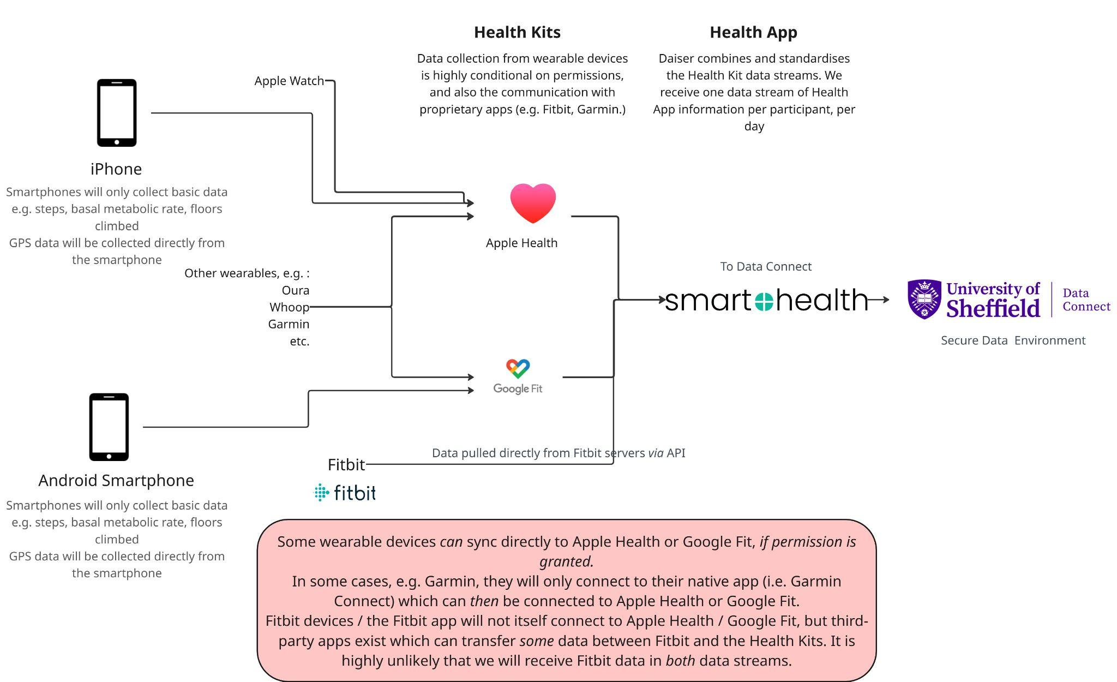
alt text: The Smart Health App stream is the daily health information collected from a participant's smartphone and any connected wearable devices, such as an Apple Watch, Garmin or Oura ring (where supported and permission has been given). The smartphone's Health app (Apple Health on iPhone or Google Fit/Health Connect on Android) brings this information together into one place. Smart Health App then organises and standardises the data into a single, consistent format, allowing the University of Sheffield's Data Connect platform to receive one combined health data record per participant each day for research purposes.

Dataflow Architecture
