Using JSTOR
JSTOR provides access to journal articles, books, and primary sources in many disciplines. This includes extensive coverage of arts and humanities, and social sciences topics.

Accessing the database

- Ensure you are signed in to your university account. Select ‘My Services’ and select ‘StarPlus’.

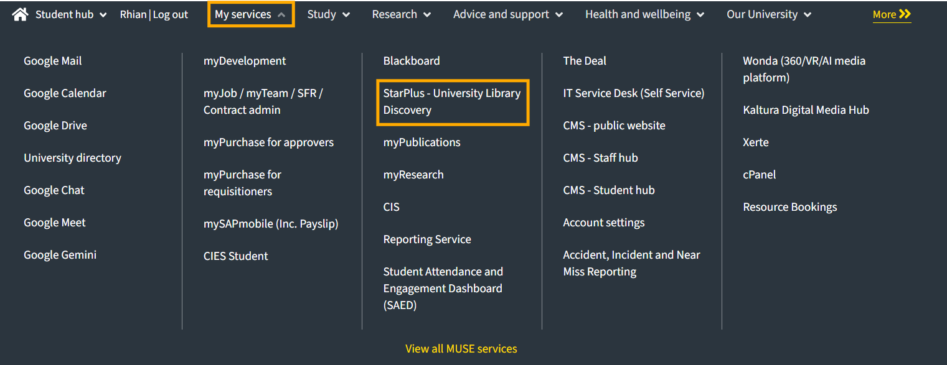

- Select ‘Database A-Z’ and browse or search for JSTOR.

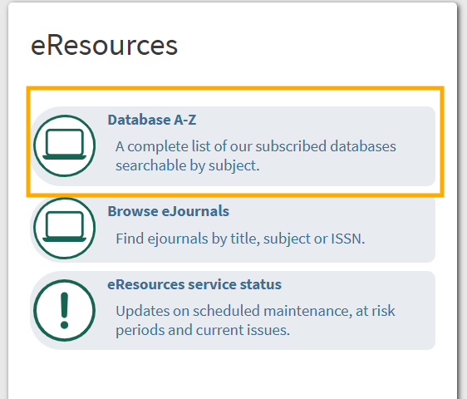

- From the database landing page, select ‘Connect to JSTOR’ to go to their site.

Conducting a search

- You can perform a basic search or an advanced search.

- To start a basic search type in your search terms.

- As you type you can choose to search specifically for an author, title, publication name, or for images.

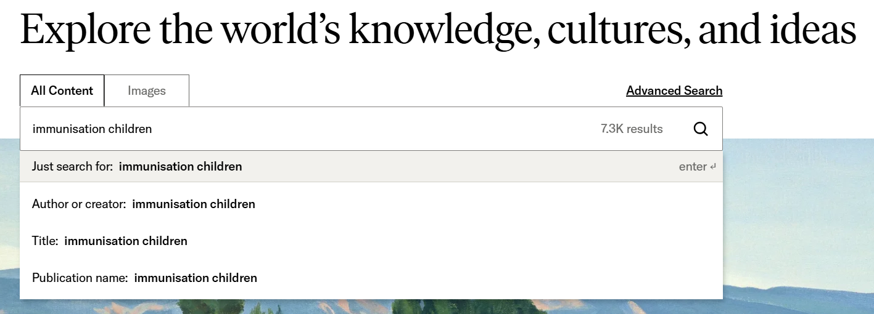

- Or to run your search without one of these filters, press Enter.

Refining and sorting search results

- From the results screen you can further focus your search by adding another term.
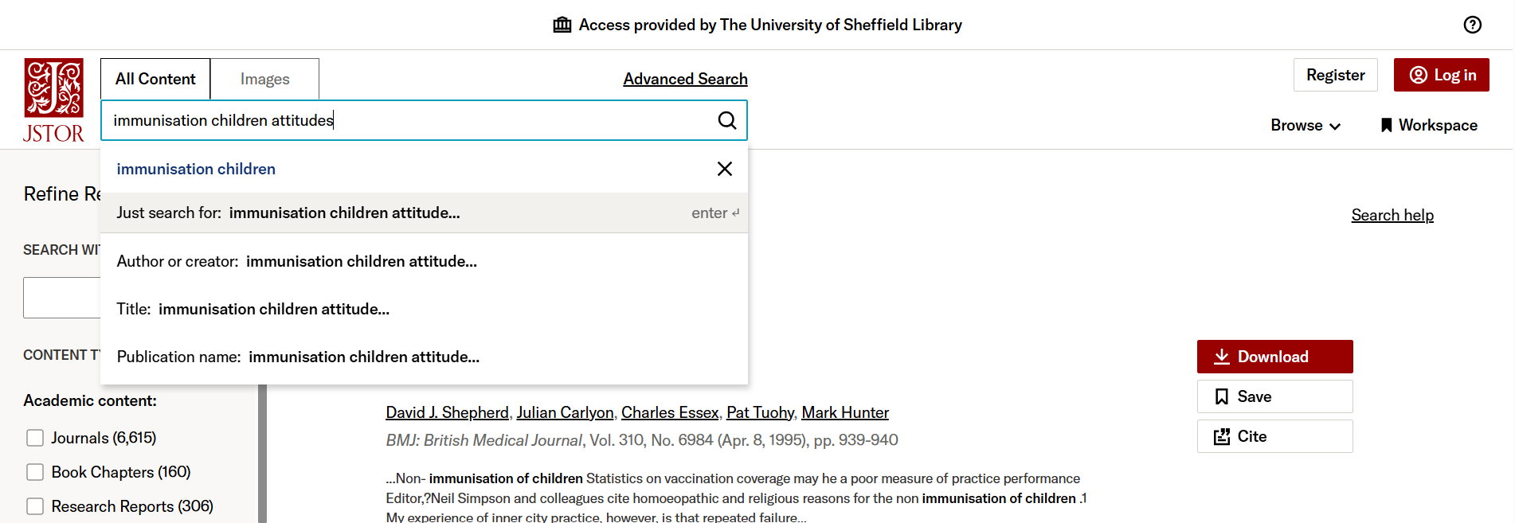

- You can refine your results using the column on the left.

- You can sort your results by different criteria using the ‘Sort by’ drop down menu at the top of your search results.

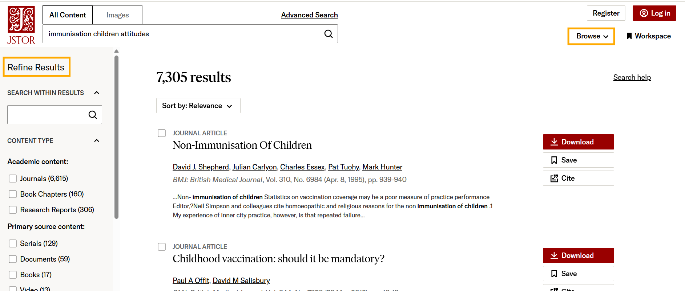

Accessing articles
- Partial abstracts or extracts are included in the results page, so you can see if an item is relevant to your topic.

- To see more information and to start reading, select the title of the item.

Last reviewed: October 2025

Except otherwise noted, this work by The University of Sheffield Library is licensed under the Creative Commons Attribution-NonCommercialShareAlike 4.0 International License. To view a copy of this license, visit http://creativecommons.org/licenses/by-nc-sa/4.0/.

