Using Business Source Premier
Business Source Premier is a business research database, providing access to leading journals and peer-reviewed business publications.

It also includes content from trade publications, market research, industry profiles and other business information materials.

Accessing the database
- Ensure you are signed in to your university account. Select ‘My Services’ and select ‘StarPlus’.

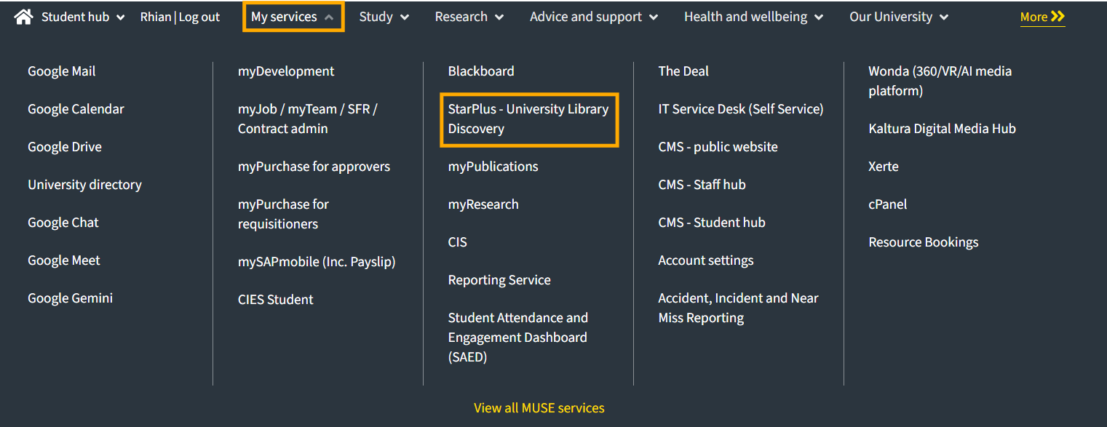

- Select ‘Database A-Z’ and browse or search for Business Source Premier.

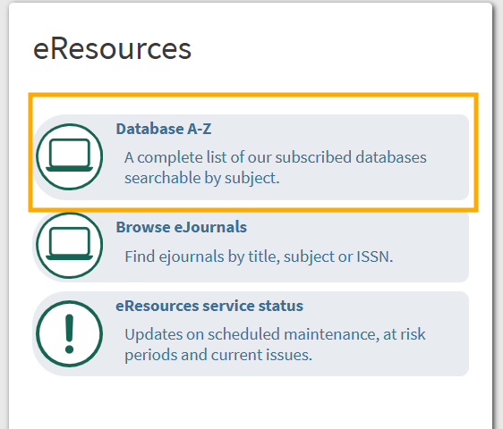

- From the database landing page, select ‘Connect to Business Source Premier’’ to go to their site.

Conducting a search
- Business Source Premier opens on the basic search screen.

- To conduct a search covering multiple concepts use the advanced search.
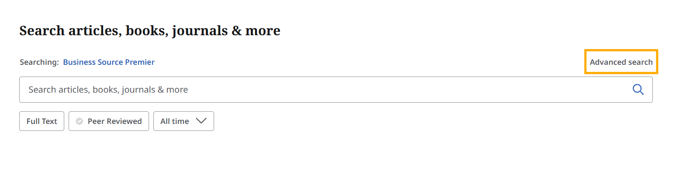

- Type in your first search term into the advanced search.

- To focus your search by adding another concept, add a second search term to a new field and use the Boolean operator ‘AND’.

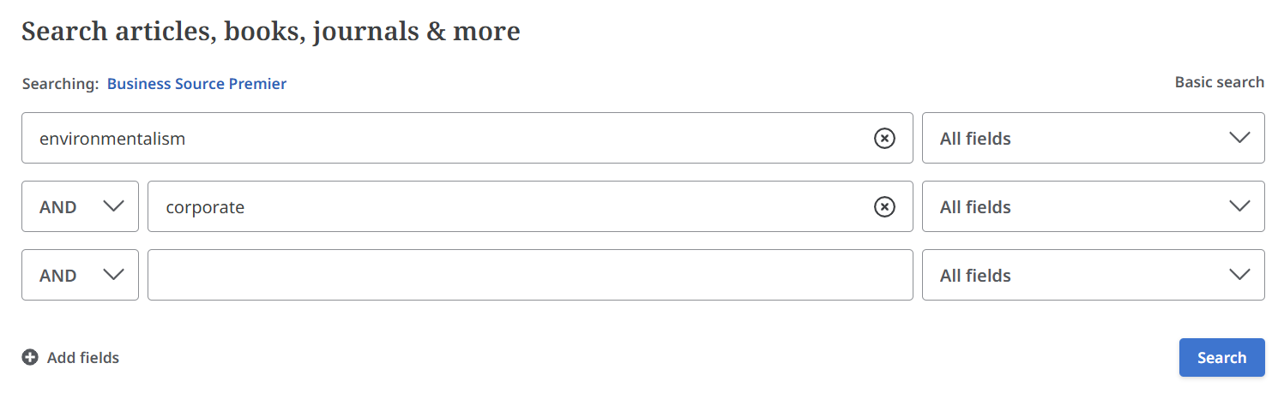
For example:

- If you are searching for a concept which is usually expressed in multiple words, put the words in quotation marks to search for them in that specific order. This is commonly referred to as ‘phrase searching’.

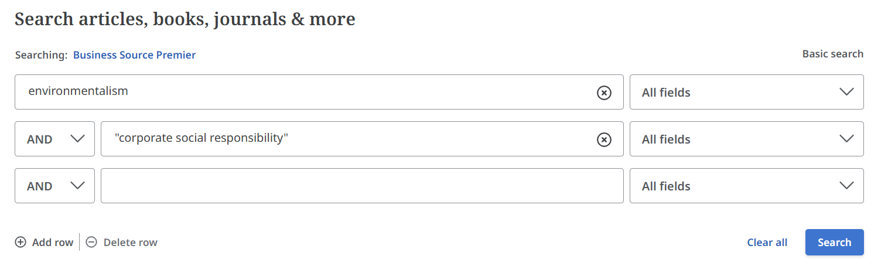
For example:

Refining and sorting search results
- From the results screen, you can sort your results by different criteria using the drop down menu on the right, or refine your search using the filter buttons at the top of your search results.
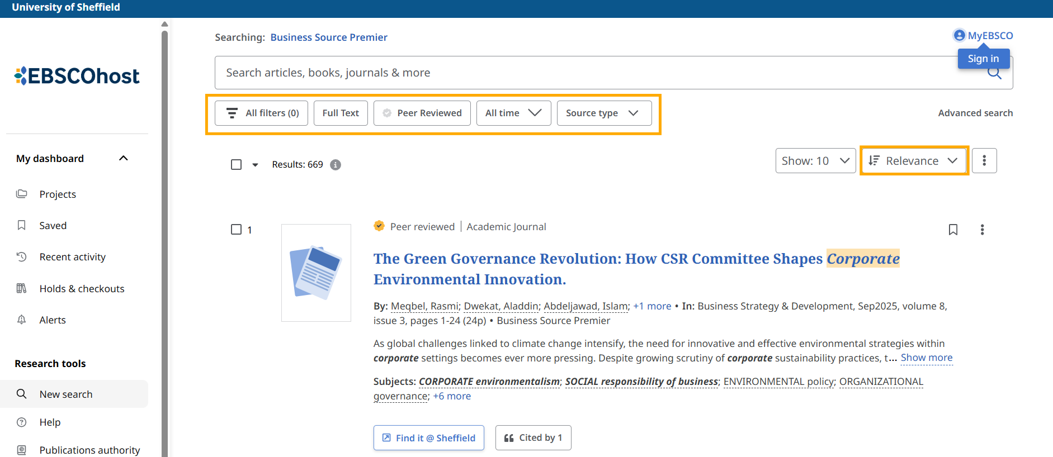

- Limiting your results to those available with ‘Full Text’ within the database means you might exclude material available to you through StarPlus via the "Find it @ Sheffield" button.

Accessing articles
- Partial abstracts are included in the results page so you can see if an article is relevant to your topic.

- To read the full abstract and see further details, select the title of the article.

- If an article is available to read straight away, you will be able to view a PDF or Linked Full Text via the access options.
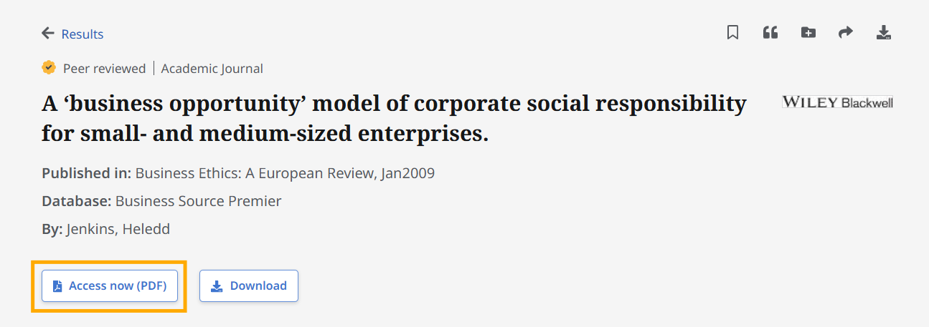

- Or select the ‘Find It @ Sheffield’ button to link through to StarPlus and check if the University Library has access to the full text of the article.

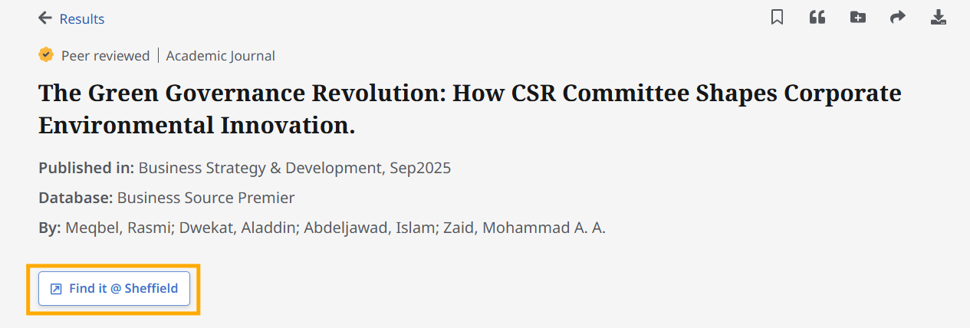

Searching for company and industry profiles
- To search for company and industry profiles enter your search terms into the Basic Search screen.

- On the Results Page, select the ‘Source Type’ drop-down button under the search box and select ‘Company Profiles’ and/or ‘Industry Profiles’.

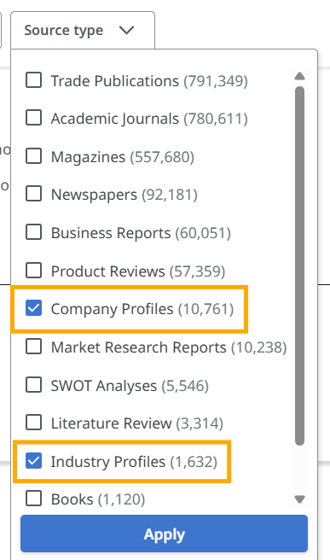

- You can also browse company information by running the search: (PZ Company Report) OR (PT Company Profiles).

- Selecting a company name will display the company’s full details and you can view the complete company report as a pdf or online full text.

Searching for SWOT Analyses and Market Research Reports
- To search for SWOT Analyses and Market Research Reports enter your search terms into the Basic Search screen.

- On the Results Page, select the ‘Source Type’ drop-down button under the search box and select ‘SWOT Analyses’ and/or ‘Market Research Reports’.

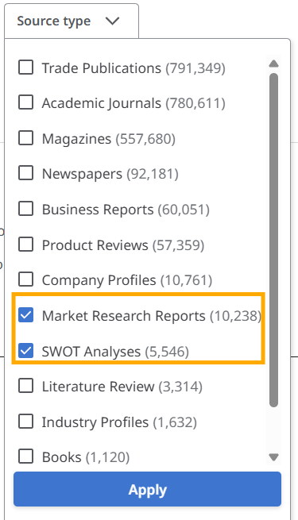

Creating an EBSCO account

- You can create your own account, which allows you to save searches and articles and set alerts.

- Select ‘myEBSCO’ from the top right corner of the webpage, then create an account or Sign in. You can use this account across all databases hosted by EBSCO that the University Library has access to.

Last reviewed: October 2025

Except otherwise noted, this work by The University of Sheffield Library is licensed under the Creative Commons Attribution-NonCommercialShareAlike 4.0 International License. To view a copy of this license, visit http://creativecommons.org/licenses/by-nc-sa/4.0/.

